THE REIGN OF THE
SACRED HEART OF JESUS
IN OUR HOME,
OUR HEARTS,
AND OUR FAMILY
THY KINGDOM COME!

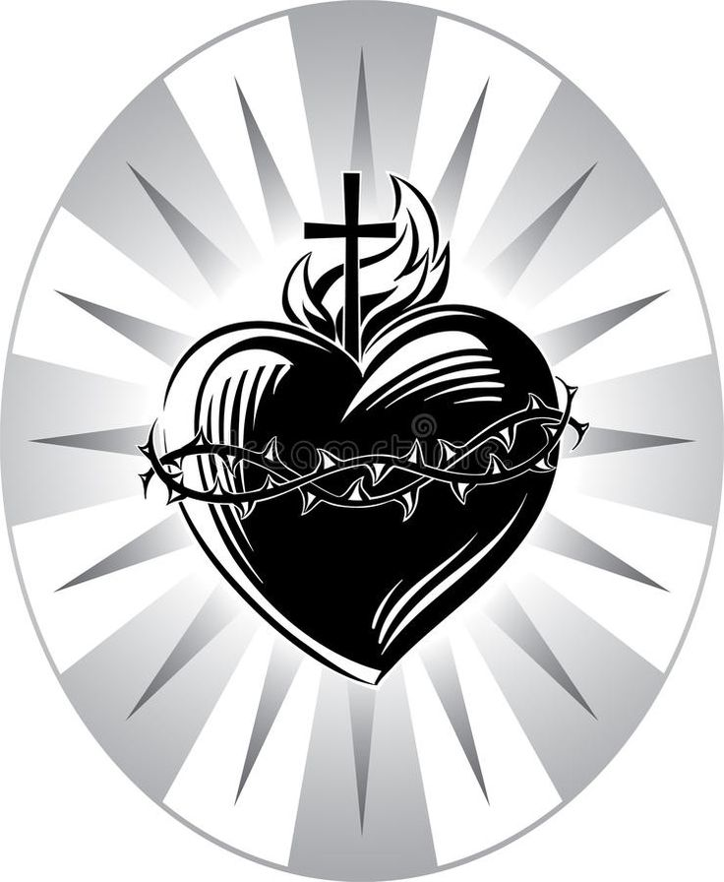

DEDICATION OF OUR HOME AND HEARTS
TO THE SACRED HEART OF JESUS
The enthronement or dedication to the Sacred Heart is a spiritual practice intended to help families in particular. Begun by Father Mateo Crowley-Boevey, a priest of the Congregation of the Sacred Hearts of Jesus and Mary, his goal was to establish the Devotion to the Sacred Heart among families, to strengthen them in their lives together, and to bring them closer to God.
The family is often called a domestic Church. In other words, it is like the Church in miniature. A good family life provides the strong foundation for faith to flourish. The practice of enthronement involves putting an image of the Sacred Heart of Jesus in the home. The image should be blessed by a priest and displayed in a prominent place. After the image has been set in place, the Act of Consecration of the family to the Sacred Heart Is prayed aloud by the entire family. This consecration can be renewed on solemn feasts such as Christmas, Easter, and Corpus Christi.
The image of the Sacred Heart can serve as the focal point for the family’s prayer times together. By honoring Jesus in this way, the family members acknowledge the presence of Jesus in their midst. They turn to him often with their prayers and love, and ask for help in times of trouble. They will not be disappointed, for Jesus promised to bless families consecrated to his Sacred Heart: "I will bless those homes where an image of my heart is displayed and venerated. I shall give peace in their families. I shall bless all their undertakings. I shall be their safe refuge in life and especially at the hour of death."

CEREMONY
Blessing of Image

If a priest or Deacon is present, he blesses the image of the Sacred Heart as follows. (if no priest or Deacon is present, the image is blessed in advance.)

Priests or Deacon:
Our help is in the name of the Lord

Family:
Who made Heaven and earth.

Priest or Deacon:
The Lord be with you.

Family:
And with your spirit.

Priest or Deacon:
Let us pray. Almighty, everlasting God, who approved the painting and sculpturing of the images of your Saints, so that as often as we gaze upon them we are reminded to imitate their deeds and sanctity: in your kindness we implore you to bless and sanctify this image made an honor and in memory of the most Sacred Heart of your only begotten Son, our Lord Jesus Christ. Grant that whosoever in its presence humbly strives to serve and honor the Sacred Heart of your only begotten Son may obtain, through his merits and intercession, grace in this life, and everlasting glory in the world to come.
Family: Amen.

PRAYERS AT HOME

Reading -- A passage of scripture may be read such as:

Matthew 11:28-30 - “Come to me, all you who labor and are burdened, and I will give you rest. Take my yoke upon you and learn from me, for I am meek and humble of heart; and you will find rest for yourselves. For my yoke is easy, and my burden light.”

John 10:10-11 – I came so that they might have life and have it more abundantly. I am the good shepherd. A good shepherd lays down his life for the sheep.

John 7:37-38 - On the last and greatest day of the feast, Jesus stood up and exclaimed, “Let anyone who thirsts come to me and drink. Whoever believes in me, as scripture says: ‘Rivers of living water* will flow from within him.

John 8:12 - Jesus spoke to them again, saying, “I am the light of the world. Whoever follows me will not walk in darkness, but will have the light of life.

John 6:35 - Jesus said to them, “I am the bread of life; whoever comes to me will never hunger, and whoever believes in me will never thirst.

John 14 6-7 - Jesus said to him, “I am the way and the truth* and the life. No one comes to the Father except through me. If you know me, then you will also know my Father.* From now on you do know him and have seen him.”

John 13 34-35 - I give you a new commandment: love one another. As I have loved you, so you also should love one another. This is how all will know that you are my disciples, if you have love for one another.”

John 13 13-14 - You call me ‘teacher’ and ‘master,’ and rightly so, for indeed I am. if I, therefore, the master and teacher, have washed your feet, you ought to wash one another’s feet.

John 14:27 - Peace I leave with you; my peace I give to you. Not as the world gives do I give it to you. Do not let your hearts be troubled or afraid.

Enthronement
The father (or mother) takes the Sacred Heart image and places it in a place of honor prepared for it. Other family members may place a Bible and candles nearby.
All pray the Apostles’ Creed: I believe in God, the Father Almighty, Creator of heaven and earth, and in Jesus Christ, His only Son, our Lord, who was conceived by the Holy Spirit, born of the Virgin Mary, suffered under Pontius Pilate, was crucified, died and was buried; He descended into hell; on the third day He rose again from the dead; He ascended into heaven, and is seated at the right hand of God the Father Almighty; from there He will come to judge the living and the dead. I believe in the Holy Spirit, the Holy Catholic Church, the communion of Saints, the forgiveness of sins, the resurrection of the body, and life everlasting. Amen.
Act of Consecration of the Family to the Sacred Heart:
Most loving heart of Jesus, you gave Saint Margaret Mary the consoling promise that you would bless those homes in which an image of your Sacred Heart is displayed and venerated. We ask you today to accept the consecration of our family to you. By this act we intend to solemnly proclaim your Kingship over all creation and acknowledge your rule over us. O Jesus, reign over our family and over each of its members. Reign over our minds that we may always remain steadfast in the truth you have taught. Reign over our hearts, that we may always follow your teachings. O Divine Heart, you alone are our loving Redeemer, for we have been purchased at a great price, your own precious Blood.
Uphold your promise Lord Jesus, and grant us your blessings. Bless us in our labors, in our undertakings, in our health, in our interests. Bless us in joy and in sorrow, in prosperity and adversity, now and always. Grant that peace may reign among us, and allow harmony, respect, mutual love and good example to direct our every action.
Preserve us from danger, grave illness, critical accidents, and above all, from serious sin. Write each of our names in your Sacred Heart and grant that they always remain there, so that, after having been united with you on earth, we may one day be united with you in heaven to sing the glories and the triumphs of your mercy. Amen.
All pray together and Our Father and Hail Mary for all absent family members living and deceased, that they will receive the benefit of the enthronement.

Our Father
Our Father, Who art in Heaven, hallowed be Thy name; Thy Kingdom come, Thy will be done on earth as it is in Heaven. Give us this day our daily bread; and forgive us our trespasses as we forgive those who trespass against us; and lead us not into temptation, but deliver us from evil. Amen.

Hail Mary
Hail Mary full of Grace, the Lord is with thee. Blessed art thou among women and blessed is the fruit of thy womb Jesus. Holy Mary Mother of God, pray for us sinners now and at the hour of our death. Amen.

All family members sign the Certificate of Enthronement

DAILY FAMILY PRAYERS
TO THE SACRED HEART OF JESUS

Daily Covenant Prayer
to the Sacred Heart of Jesus

‘“Behold, I stand at the door and knock. If anyone hears my voice and opens the door, [then] I will enter his house and dine with him, and he with me. Rev. 3: 20

Most sweet Jesus, humbly kneeling at your feet, we renew the consecration of our family to your Divine Heart. Be our King forever. In you we have full and entire confidence. May your Spirit penetrate our thoughts, our desires, our words and our works. Bless our undertakings, share in our joys, in our trials and in our labors. Grant us to know you more, and to serve you without faltering.
By the Immaculate Heart of Mary Queen of Peace, set up your kingdom in our country. Enter closely into the midst of our families and make them your own through the solemn enthronement of your Sacred Heart; so that one cry may resound from home to home: May the triumphant Heart of Jesus be everywhere loved, blessed, and glorified forever! Honor and glory to the Holy Hearts of Jesus and Mary!
Sacred Heart of Jesus, please protect our families. Amen.

Consecration Prayer of St. Margaret Mary:

I give myself and consecrate to the Sacred Heart of our Lord Jesus Christ, my person and my life, my actions, pains and sufferings, so that I may be unwilling to make use of any part of my being save to honor, love and glorify the Sacred Heart.
This is my unchanging purpose, namely, to be all His, and to do all things for the love of Him, at the same time renouncing with all my heart whatever is displeasing to Him.
I therefore take you, O Sacred Heart, to be the only object of my love, the guardian of my life, my assurance of salvation, the remedy of my weakness and inconstancy, the atonement of all the faults of my life, and my sure refuge at the hour of death.
Be then, O Heart of goodness, my justification before God your Father, and turn away from me the strokes of His righteous anger. O Heart of love, I put all my confidence in you, for I fear everything from my own wickedness and frailty, but I hope for all things from your goodness and bounty.
Consume in me all that can displease you or resist your holy will; let your pure love imprint you so deeply upon my heart that I shall nevermore be able to forget you or to be separated from you; may I obtain from all your loving kindness the grace of having my name written in you, for in you I desire to place all my happiness and all my glory, living and dying in very bondage to you.

LITANY TO THE MOST SACRED HEART OF JESUS

Lord, have mercy. Christ, have mercy
Lord, have mercy. Christ, hear us.
Christ, graciously hear us.

God our Father in heaven, … have mercy on us.
God the Son, Redeemer of the world,
Holy Trinity, one God,
Heart of Jesus, Son of the eternal Father
Heart of Jesus, formed by the Holy Spirit in the womb of the Virgin Mother,
Heart of Jesus, substantially united to the Word of God.
Heart of Jesus, of infinite majesty,
Heart of Jesus, sacred temple of God,
Heart of Jesus, tabernacle of the Most High,
Heart of Jesus, house of God and gate of heaven,
Heart of Jesus, burning Furnace of charity,
Heart of Jesus, abode of justice and love,
Heart of Jesus, full of goodness and love,
Heart of Jesus, abyss of all virtues,
Heart of Jesus, most worthy of all praise,
Heart of Jesus, king and center of all hearts,
Heart of Jesus, in Whom are all the treasures of wisdom and knowledge,
Heart of Jesus, in whom there dwells the fullness of God,
Heart of Jesus, in whom the Father is well pleased,
Heart of Jesus, from whose fullness we have all received,
Heart of Jesus, desire of the eternal hills,
Heart of Jesus, patient and full of mercy,
Heart of Jesus, enriching all who invoke you,
Heart of Jesus, fountain of life and holiness,
Heart of Jesus, propitiation for our sins,
Heart of Jesus, loaded down with opprobrium,
Heart of Jesus, bruised for our offenses,
Heart of Jesus, obedient unto death,
Heart of Jesus, pierced with a lance,
Heart of Jesus, source of all consolation,
Heart of Jesus, our life and resurrection,
Heart of Jesus, our peace and reconciliation,
Heart of Jesus, victim for our sins,
Heart of Jesus, salvation of those who trust in you,
Heart of Jesus, hope of those who die in you,
Heart of Jesus, delight of all the saints.

Lamb of God, you take away the sins of the world, spare us, O Lord.
Lamb of God, you take away the sins of the world, graciously hear us, O Lord.
Lamb of God, you take away the sins of the world, have mercy on us.

Jesus, meek and humble of Heart,
Make our hearts like to Yours.

Let us pray.
Let us pray, Almighty and Eternal God, look upon the Heart of Your most beloved Son and upon the praises and satisfaction which He offers You in the name of sinners; and to those who implore Your mercy, in Your great goodness, grant forgiveness in the Name of the same Jesus Christ, Your son, who lives and reigns with You forever and ever.
Amen.

Recommended Practices:
- Frequent reception of the Holy Communion
- Faithful use of the Sacrament of Reconciliation
- Scripture and Scriptural Readings
- Holy Hours in the home and Eucharist Adoration
- Monthly First Friday and First Saturday devotions
- Celebrations of Solemnities of Feast of Corpus Christi, Sacred Heart, Immaculate Heart of Mary and Christ the King
- Making a difference for Christ in society and in your parish
- Pray the Rosary Daily
- Spread the devotion- share hope and healing with others through the Enthronement

Enthronement prayers based on excerpts from the Sacred Heart of Jesus prayer book written and compiled by Marianne Lorraine Trouve, FSP, Pauline Books and Media, Boston, c. 2016, pp. 95-100.
Daily Prayers taken from Online website of the Sacred Heart Enthronement Network
Prayer of Saint Margaret Mary – Taken from translation from the Polish by the Sister Servants of the Most Sacred Heart of Jesus (www.sacredheartsisters.org.)

